YOU’RE STEP BY STEP GUIDE TO A VIRTUAL PLATFORM EXPERIENCE
Prior to login please make sure you have the below requirements
SYSTEM REQUIREMENTS:
- Minimum 3 GB RAM required
- 50 GB ROM free storage should be free in the C Drive.
- Recommended Browsers to run the VR Platform: Chrome / Firefox / Opera.
- Whenever opening the African Investment Immigration Virtual platform open in fresh browser. I.e. remove all the browser cache & History.
- If any popup blockers are blocked kindly unblock those popup options.
- Don’t run the African Investment Immigration Virtual Platform in VPN enabled browsers.
How you can enter the African Investment Immigration Virtual Platform?
Go to www.giisummit.org and click Register now
or click the below URL for registration as an visitor/attendee
https://giisafrica.citizenshipinvestment.org/attendee-registration/
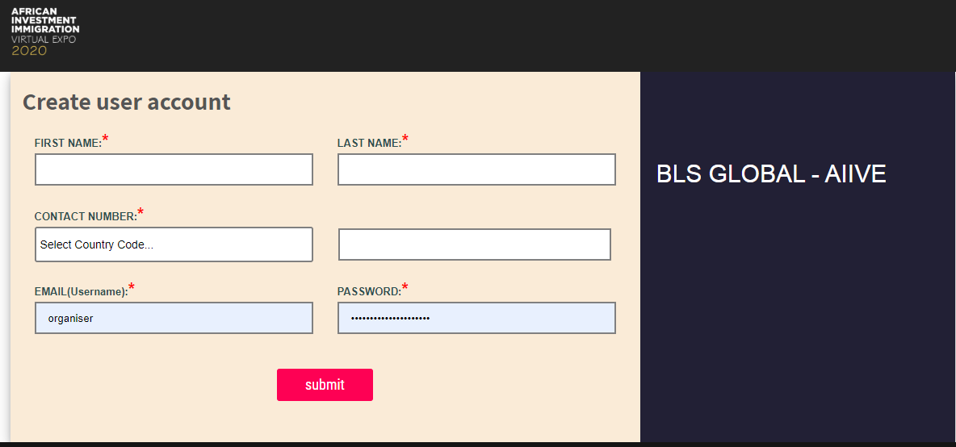
Enter the following details
- First Name
- Last Name
- Contact Number Select Country Code
- Enter Number (Must be 10 digits)
- Email Id
- Password (Must be 6 digits)

You will get this
Successful registration message with “CLICK HERE TO LOGIN” to African Investment Immigration Virtual Platform message will be shown.
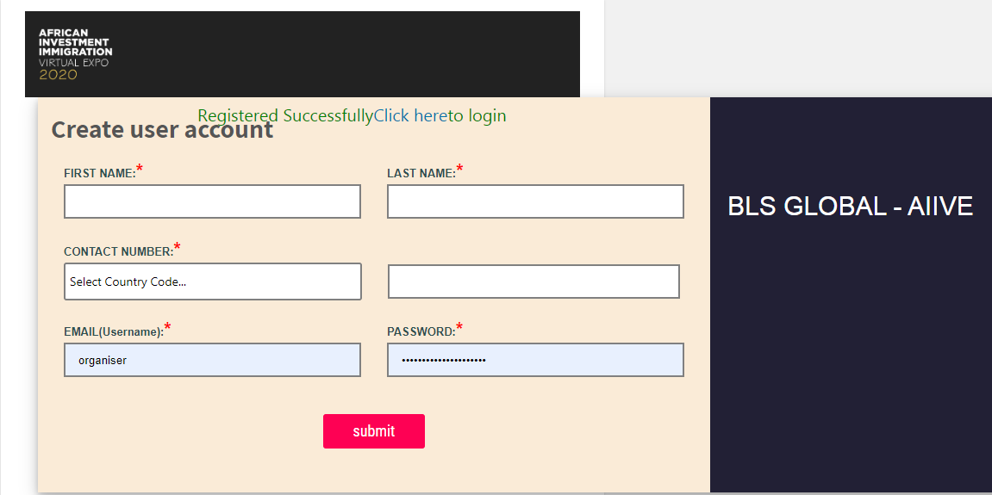
Enter
- First Name
- Last Name
- Contact Number Select Country Code
- Enter Number (Must be 10 digits)
- Email Id
- Password (Must be 6 digits)
Then you will be directed to https://giisafrica.citizenshipinvestment.org/live/index.html
Using the above link visitors can enter the African Investment Immigration Virtual Platform.
You will get this
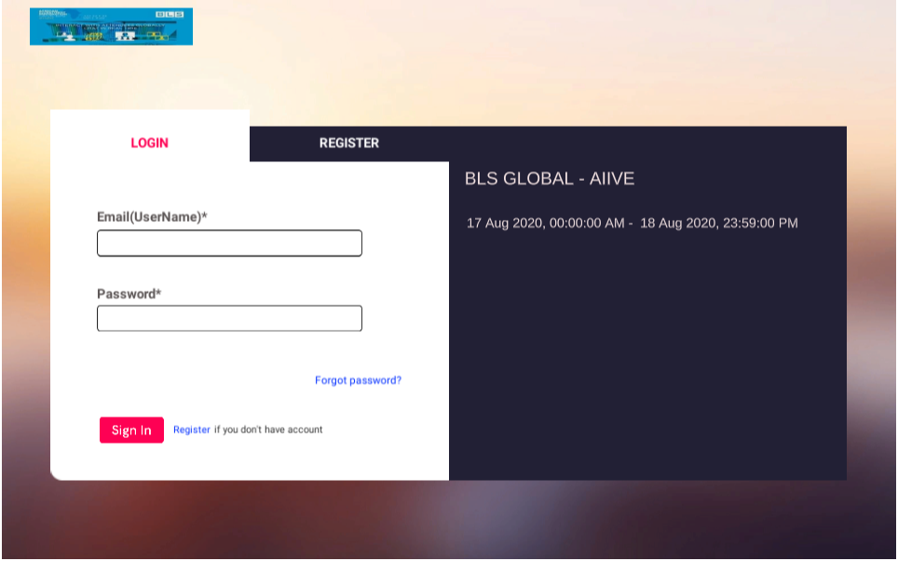
You will get a conformation email for successful registration. Inside the email the Live VR Platform URL: https://giisafrica.citizenshipinvestment.org/live/index.html
Insert your username and Password and Sign In get this image
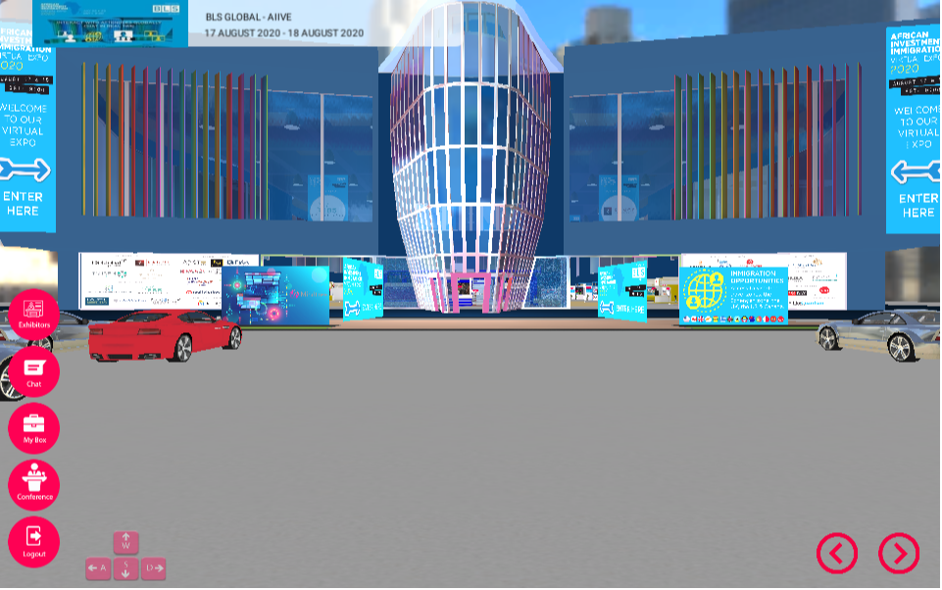
How to navigate the Virtual Platform
- Connect with Exhibitors and sponsors
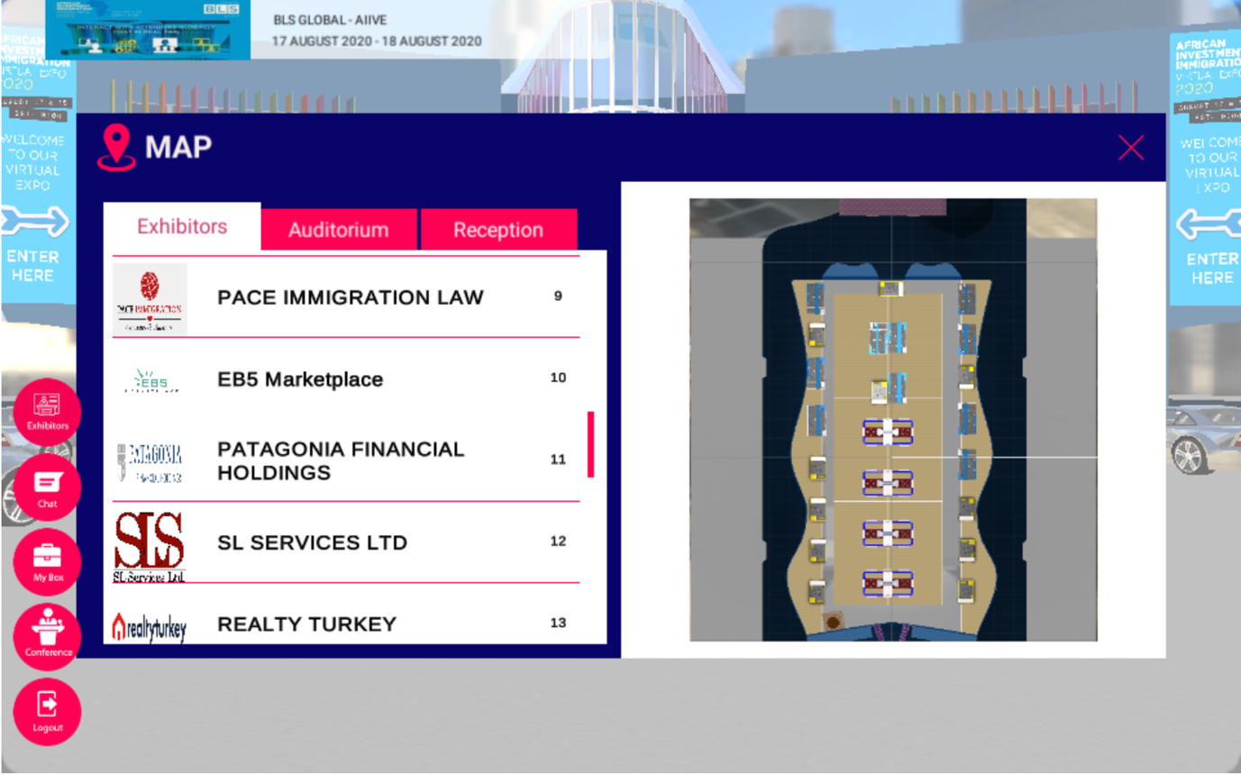

- How to? Click
Company Information Exchange Business Cards Chat Email Exchange

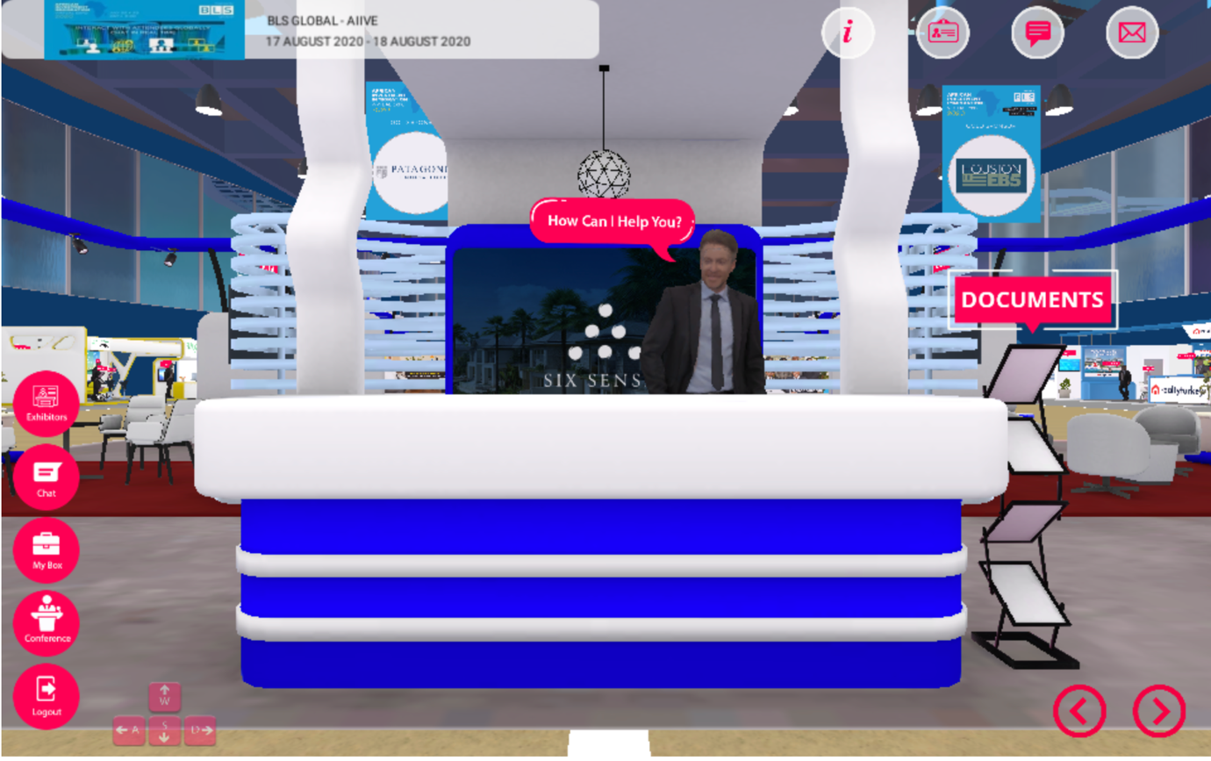
- How to?
Watch Video Download Documents

- How to Listen to Speakers, Select the Auditorium icon
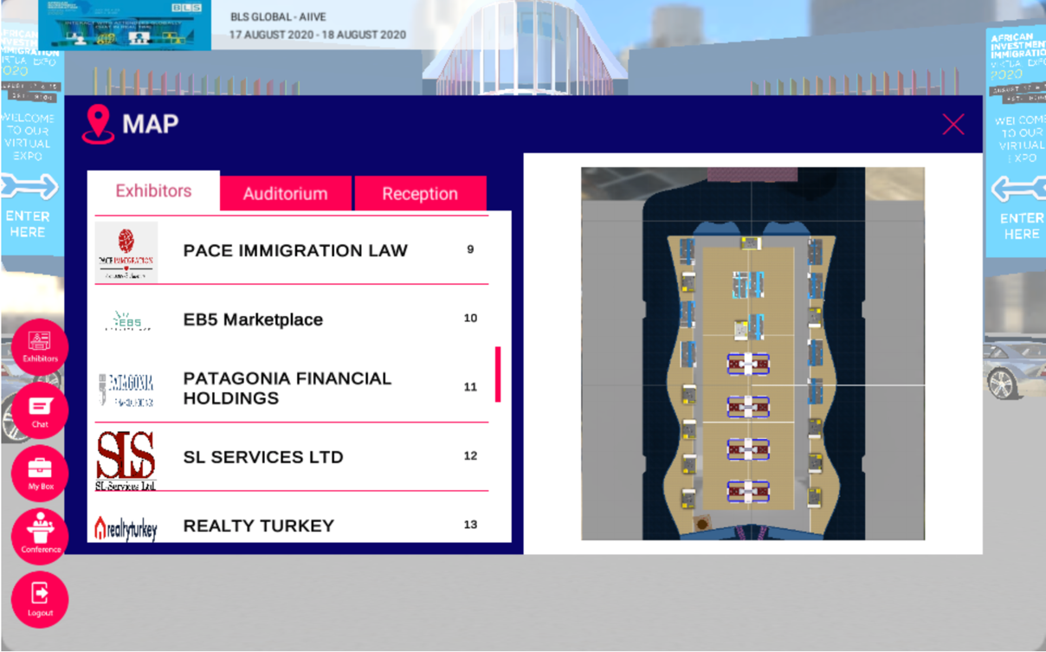
- Enter the Auditorium and select the play button
